**Experiment no – 04(a)**

**Aim**: **a. Write a program to print the pattern of asterisks as shown below :**

*

* *

* * *

* * * *

**Algorithm:**

Display * and go to new line

Step 2: Display * * and go to new line.

Step 3: Display * * * and go to new line.

Step 4: Display * * * *

Display * and go to new line

Step 2: Display * * and go to new line.

Step 3: Display * * * and go to new line.

Step 4: Display * * * *

Display * and go to new line

Step 2: Display * * and go to new line.

Step 3: Display * * * and go to new line.

Step 4: Display * * * *

1. Display * and go to new line
2. Display * * and go to new line.
3. Display * * * and go to new line.
4. Display * * * *

**Code:**

*#include<stdio.h>*

*int main()*

*{ printf("01-AlstonAlvares.\n");*

*int i, j, n;*

*/* for used as row wise */*

*for(i=1; j<=4; ++i)*

*{*

*/* for used as column wise */*

*for(j=1; j<=i; ++j)*

*{*

*printf("*");*

*}*

*printf("\n");*

*}*

*return 0;*

*}*

**Output:**

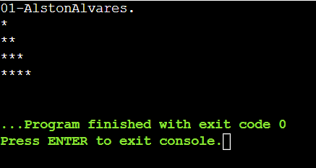

**Experiment no – 04(b)**

**Aim: Write a program to print the pattern of asterisks as shown below :**

**\* * * * \***

**\* * * \***

**\* * \***

**\* \***

**\***

**Algorithm:**

1. Display ***** and go to new line
2. Display * * **and go to new line.
3. Display * * * and go to new line.
4. Display * * and go to new line.
5. Display *

**Code:**

*#include<stdio.h>*

*int main()*

*{ printf("01-AlstonAlvares.\n");*

*int i, j;*

*/* for used as row wise */*

*for(i=5; i>=1; i--)*

*{*

*/* for used as column wise */*

*for(j=1; j<=i; j++)*

*{*

*printf("*");*

*}*

*printf("\n");*

*}*

*return 0; }*

**Output:**

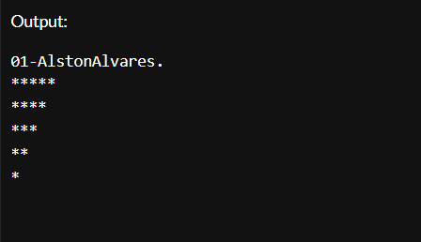

**Experiment no – 04(c)**

**Aim: Write a program to print Floyd’s Triangle.**

**Algorithm:**

1. Create variables that hold rows and column values as i and j. Take a number to display the rows as num and set the variable k to 1as its initial value.
2. Use nested for loops:
   1. Outer for loop starts its iteration i = 1 up to n rows.
   2. Inner for loop starts its iteration from j = 1 up to (j <=i).
3. Print the values of k.
4. Increment k by 1 or k = k + 1.
5. Jump to newline after each iteration of the inner for loop.
6. Stop

**Code:**

*#include <stdio.h>*

*int main()*

*{ printf("01-AlstonAlvares\n");*

*int n, i, c, a = 1;*

*printf("Enter the number of rows of Floyd's triangle to print\n");*

*scanf("%d", &n);*

*for (i = 1; i <= n; i++)*

*{*

*for (c = 1; c <= i; c++)*

*{*

*printf("%d ", a); // Please note space after %d*

*a++;*

*}*

*printf("\n");*

*}*

*return 0;*

*}*

**Output:**

